EECE5644 Fall 2019 – Exam 1

Alan Luke Jacob

NU ID: 001056590

# Question 1:

Plots and Figures:

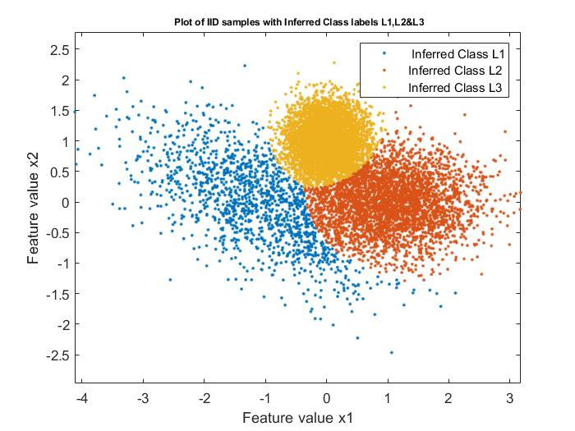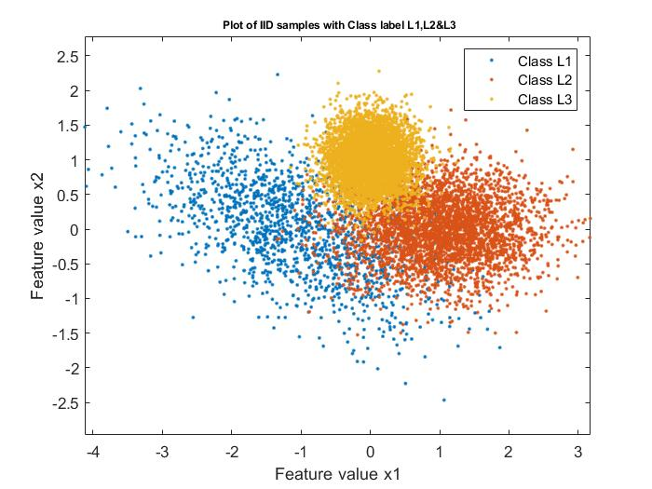

Number of samples generated for Class 1: 1444

Number of samples generated for Class 2: 3555

Number of samples generated for Class 3: 5001

Number of samples inferred as Class 1: 1335

Number of samples inferred as Class 2: 3486

Number of samples inferred as Class 3: 5179

The number of Misclassification errors:

781

Probability of error:

0.0781

The Confusion matrix is given as:

C = 1172 205 67

138 3176 241

25 105 4871

Confusion Chart:

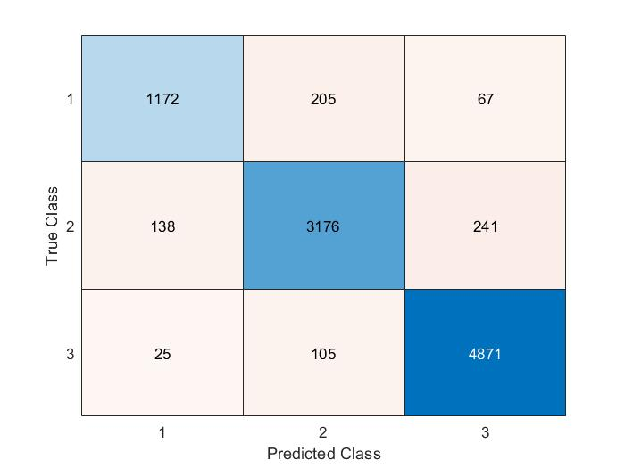

From the confusion chart it can be observed that the number of samples generated for class 1 is 1444. The classifier correctly classified 1172 samples as class 1. We observe that 205 and 67 samples from True class 1 were incorrectly predicted as class 2 and class 3 respectively.

The number of True class samples generated for class 2 is 3555. Out of these the classifier correctly predicted 3167 samples as class 2 and 138, 241 Samples of true class 2 were incorrectly predicted as class 1 and class 3 respectively.

The number of True class samples generated for class 3 is 5001. Out of these the classifier correctly predicted 4871 samples as class 3 and 25, 105 Samples of true class 2 were incorrectly predicted as class 1 and class 2 respectively.

# Question 2:

Plots and Figures:

Case 1.

K=1

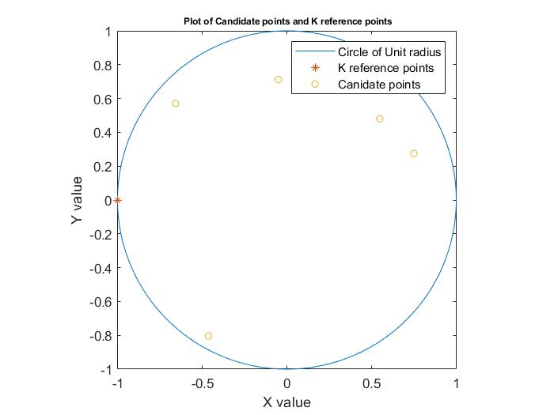

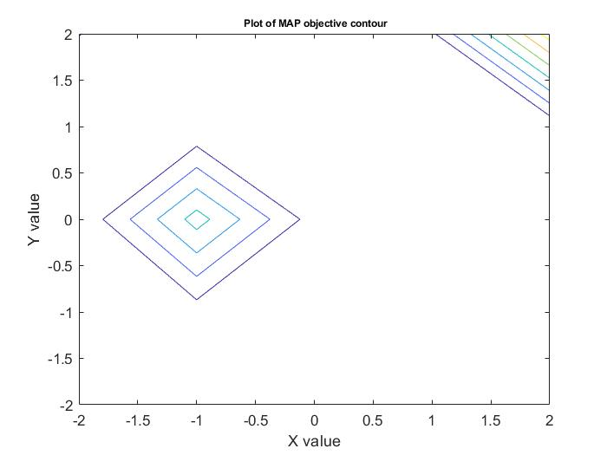

The given R range measurements for the 5 candidate points is given by

1.1076

1.7901

1.9272

1.0881

1.1761

The number of misclassifications is given as: 3

The Probability of error is given by: 0.6000

True Label: 1 2 3 4 5

Inferred Label: 5 3 3 5 5

Case .

K=2

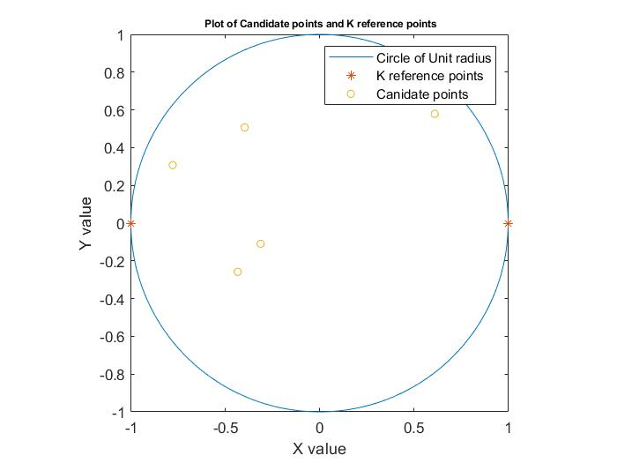

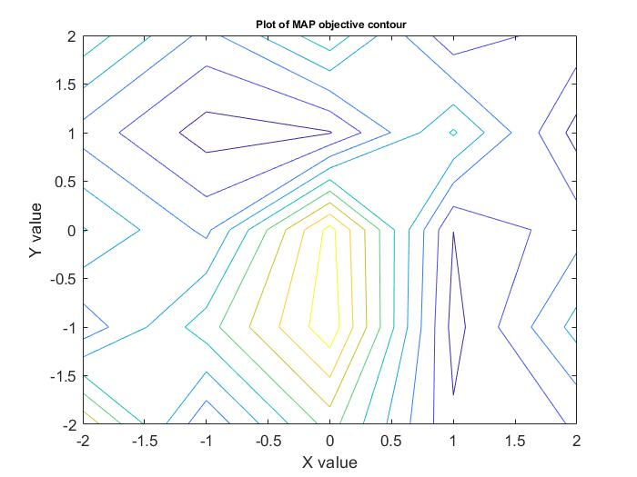

The given R range measurements for the 5 candidate points is given by

0.9174 1.0380

0.4646 2.2716

0.3284 1.5183

2.1090 1.0137

0.6309 2.3250

The number of misclassifications is given as: 2

The Probability of error is given by: 0.4000

True Label: 1 2 3 4 5

Inferred Label: 1 2 2 4 2

Case 3.

K=3

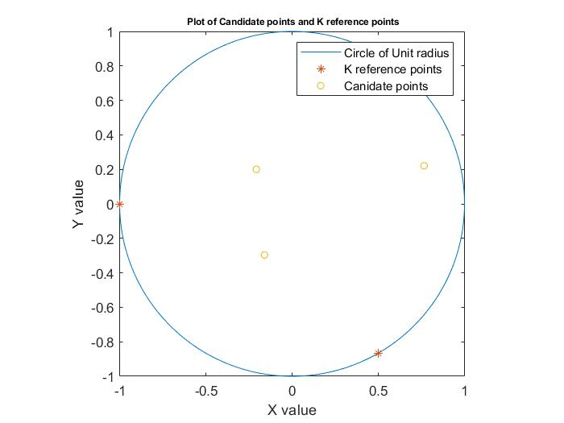

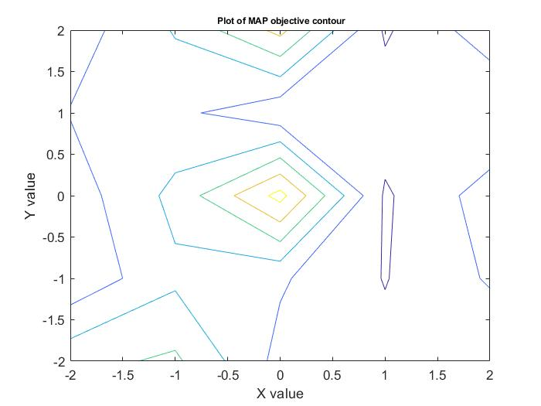

The given R range measurements for the 5 candidate points is given by

0.4164 1.5419 1.0520

1.1977 1.3599 0.7960

1.3419 1.4658 0.0736

0.9496 1.4090 2.3433

2.0576 1.8494 0.3800

The number of misclassifications is given as: 2

The Probability of error is given by: 0.2000

True Label: 1 2 3 4 5

Inferred Label: 1 1 3 4 5

Case 4.

K=4

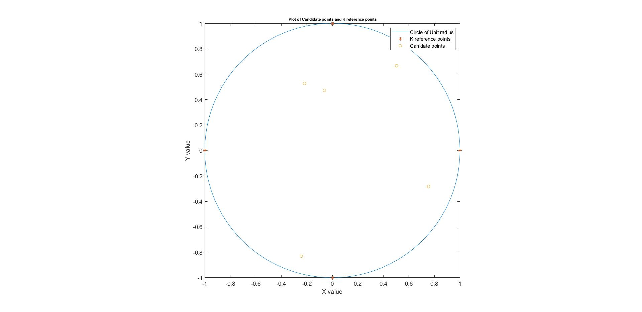

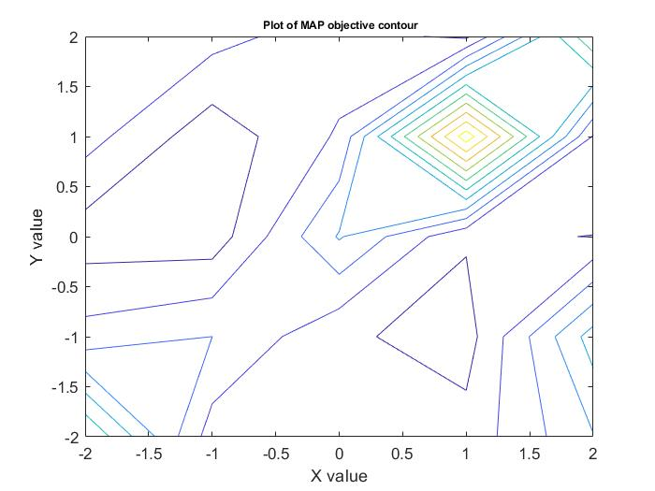

The given R range measurements for the 5 candidate points is given by

1.7440 2.0493 0.8583 1.0831

0.8973 2.2218 1.9703 0.9913

1.5347 0.1532 1.1897 1.1704

2.0189 0.8657 0.1969 1.6558

1.0760 1.0880 0.8167 0.4327

The number of misclassifications is given as: 0

The Probability of error is given by: 0

True Label: 1 2 3 4 5

Inferred Label: 1 2 3 4 5

It can be observed from the results that as the value of K increases the Xmap, Ymap becomes closer and equal to the true values of the considered 5 Candidate positions Xt,Yt. The number of misclassifications and probability of error decreases as the number of K increases. This can be intuitively explained by that as K increases we have more number of measurements to localize the point Xt,Yt and hence it is localized more accurately. The height of the MAP estimate contour function seems to be more concentrated at the origin as K increases.

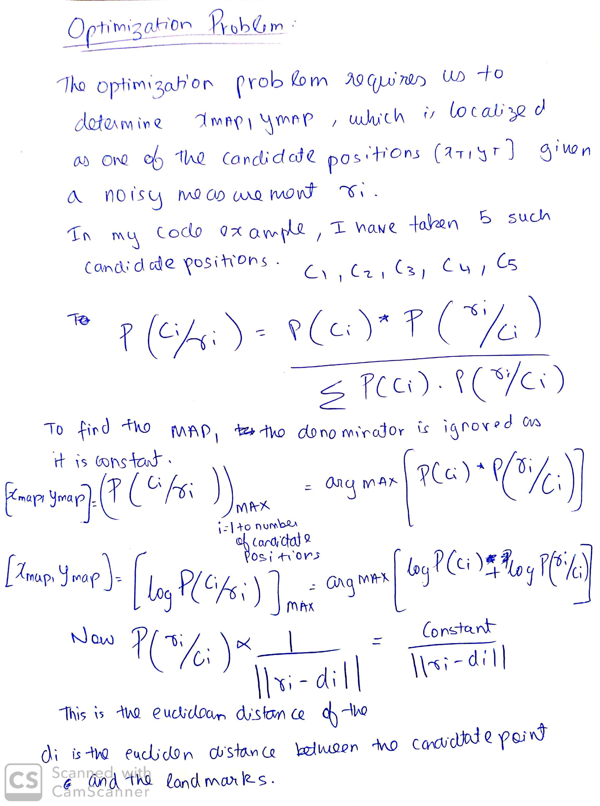Optimization Problem:

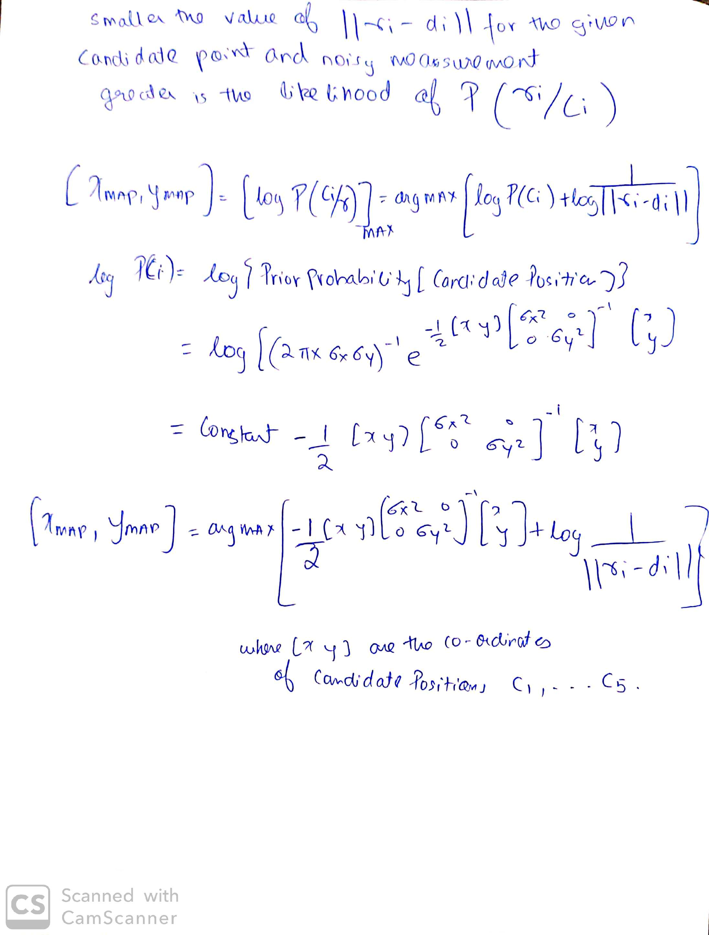

# Question 3:

Plots and Figures:

